COPYMASTER |  | COPY TONE: Entry Level |  |  |  | VERSION: 1.0
Project Name: |  | Product Name: Acer Mouse 570 Wireless |  |  |  | Product Type:  Wireless Mouse
Writer: Clark Gurden |  | Central MKT: Clark Gurden |  |  |  | FCS: 3/31/26
NOTE TO EDITORS: If you would like to leave feedback or a correction, do it via COMMENTS.
Do not edit copy directly.
//AGW Meta Content
Page Title (60) |  | Acer Mouse 570 Wireless | Multi-Mode Wireless Mouse
Meta Description (160) |  | Move seamlessly between wired, 2.4 GHz RF and Bluetooth connections with this multi‑mode mouse. Enjoy silent clicks, an ergonomic design and precise tracking with a PAW3809 sensor and adjustable DPI.
//Line/Class Content
Product Card (120) |  | Quiet, multi-mode control for everyday work and study.
//AGW Page Content / Banner
Banner Content - Product Name/Header (40) |  | Acer Mouse 570 Wireless
Key Message/Page Intro
Image Reference |  | 
 |  | One Mouse for Every Moment
Key Message/Intro (250) |  | Designed to fit smoothly into everyday work and personal setups, this wireless mouse adapts to how you move between devices. With simple switching, quiet control, and dependable performance, it helps keep daily tasks focused and uninterrupted.
Media Reviews – ENGLISH (ENG)
Publish to USA / CA
Section Headline |  | Media Reviews
Text Content
Image Selection |  | Generic | Generic |  |  |  | Generic |  |  | Generic
Reviewer Name
Quote (180 Characters)
Button & URL |  | Read More | Read More |  |  |  | Read More |  |  | Read More
Acer KSP 1
Image Reference |  |   Idea is to show flexibility to use the mouse anywhere, connect fast
KSP Headline (40) |  | Flexible Connectivity
KSP Body (220) |  | Move between devices without breaking focus. Multiple connection options and a simple switch make it easy to adapt your setup at home, at work, or on the go, without re-pairing or extra steps.
Overline (30) |  | Triple-Mode |  |  | Adjustable DPI |  |  |  | Multi-device Switching
Spec (40) |  | USB-C Wired / 2.4 GHz RF / Bluetooth |  |  | 800 / 1200 / 1600/ 2400 |  |  |  | 2.4G / Bluetooth 5.1 / BT2
Acer KSP 2
Image Reference |  | 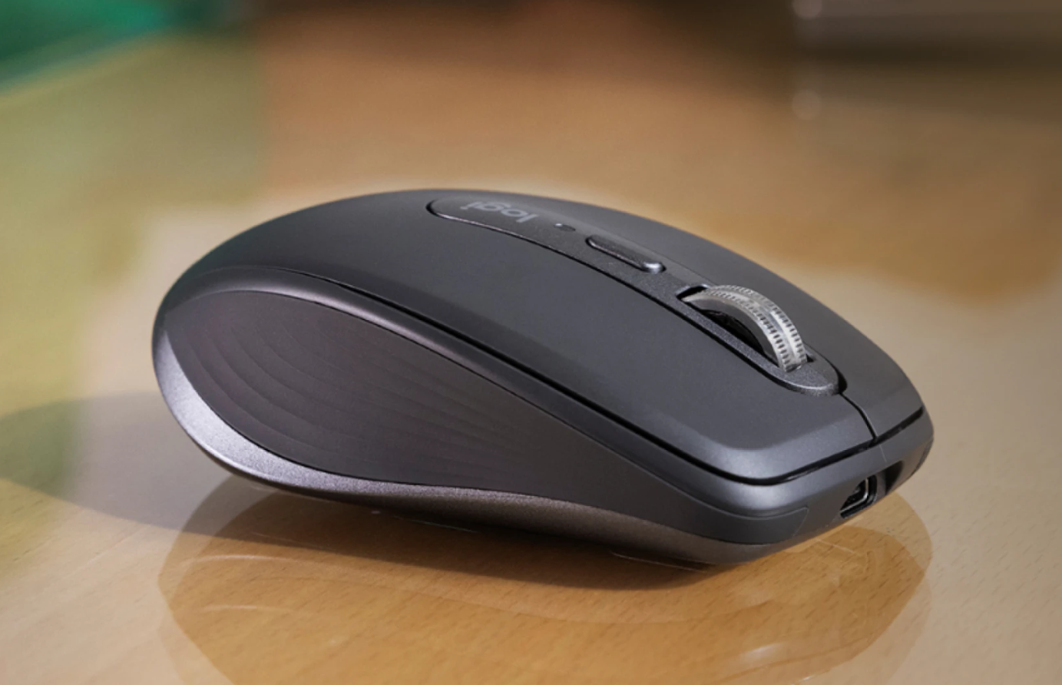  (make sure glass is shown clearly in photo)
KSP Headline (40) |  | Quiet Comfort for Shared Spaces
KSP Body (220) |  | Silent clicks reduce noise in offices, cafés, and shared spaces, while an ergonomic right-hand shape supports long work sessions. Reliable track-on-glass performance keeps control steady on desks, tables, and smooth surfaces without a mouse pad.
Overline (30) |  | Reduced Click Noise |  |  |  |  | Track-On-Glass Support
Spec (40) |  | Silent Mechanical Buttons |  |  |  |  | PAW3809 Optical Sensor
//Packaging Copy
Feature (not for use)  From High to Low | HEADLINE |  |  | BENEFIT |  |  |  | BULLETPOINT
Track-On-Glass Sensor | Works On More Surfaces |  |  | Maintains smooth control across desks and tables. |  |  |  | PAW3809 Optical Sensor
Triple-Mode Connection | Ready When You Switch |  |  | Switch easily between work, study, and personal devices. |  |  |  | USB-C / 2.4 GHz RF / Bluetooth
Silent Click Design | Quiet Clicks |  |  | Designed for shared spaces without distracting noise. |  |  |  | Silent Mechanical Buttons
DPI Control | Easy Speed Control |  |  | Adjust cursor speed to match everyday tasks. |  |  |  | 800 / 1200 / 1600 / 2400 DPI
Right-Hand Ergonomic Shape | Comfortable Right-Hand Fit |  |  | Shaped to support natural hand posture during daily use. |  |  |  | Right-Hand Ergonomic Design

